2
Modular programming with JavaScript
Engineering in general is all about splitting bigger tasks into smaller ones and composing the solutions of these tasks into the system. In software engineering we break the code-base into modules, following principles of low coupling and high cohesion. Here below we will talk about approaches to creating modules in JavaScript:

- How to get out of a mess: modular JavaScript
- How to: asynchronous modules in the browser
- How to: synchronous modules on the server
- Coming soon: JavaScript built-in module system
- Traspiling CommonJS for in-browser use

How to get out of a mess: modular JavaScript
How many digital photos do you have, probably thousands, more? Just imagine if your image viewer had no capacity to categorize. No albums, no books, no categories, nothing… It doesn’t look as of much use, does it? Now let’s assume your have a JavaScript application in a single file and it grows. When it approaches thousands or dozen thousands lines of code, whatever good is your code design, from maintainability perspective it still turns into a useless “pile” like that enormous list of uncategorized photos. Instead of building a monolithic application we had to write several independent modules, that composed together to make an application. Thus, we break a complex problem into simpler tasks.

Module
So, what is a module? Module encapsulates code intended for a particular functionality. Module also provides an interface declaring what elements it exposes and what it requires. Module is often packaged in a single file, what makes it easy to locate and deploy. A well-designed module implies low coupling (degree of interdependence between modules) and high cohesion (degree to which the elements of a module belong together)
What are the advantages modules give us in JavaScript?

Cleaner global scope
You know in JavaScript any assignation that we do out of any function scope makes a new member of the global scope (build-in object window in a browser or global in Node.js/Io.js). Therefore we are always at a risk to override accidentally already defined property. On the contrary whatever declared in a module stays there unless we explicitly export it.

Packaging code into files
In server-side languages applications consist of numerous files. One of best practices here implies that file may contain only one class and have only one responsibility. Besides fully-qualified class name must reflect its file location. So when running into a problem on an object I can easily deduct where to find its source code. We can divide JavaScript application code into separate scripts, but those will share the same scope and won’t give us any encapsulation. Moreover, when the scripts load asynchronously internal dependencies must be solved, what is not easy to do. But we go with modules, each is given a dedicated file and has own scope. Module loader takes care of asynchronous dependencies.

Reuse
Imagine, while working on a project you wrote a code that solves one task - let’s say provides a convenient API to manage cookies. When switching to another project you realize that your cookie manager would quite be in place there. In the case of “spaghetti code”, you would have to extract the component code, decouple it and bind it to the new place. If you wrote the component as a decently-designed module, you simply take it and plug it in.

Module patterns
Well, we know that modules help and we want to use them. How do we implement a module in JavaScript? First of all we need to detach the module code from the global scope. We can only do it by wrapping module code with a function. Common practice here is to go with IIFE (Immediately Invoked Function Expression):
IIFE
(function () {
"use strict";
// variable defined inside this scope cannot be accessed from outside
}());

Module must also have access points with the surrounding environment. The same way as we usually deal with function we can pass object references into IIFE as arguments.

Import
(function ( $, Backbone ) {
"use strict";
// module body
}( jQuery, Backbone ));

You may have seen also a pattern where global object (window) is passed with arguments. This way we do not access the global object directly, but by a reference. There is an opinion that the access by a local reference is faster. That’s not completely true. I’ve prepared a Codepen with some tests http://codepen.io/dsheiko/pen/yNjEar. It shows me that in Chrome (v45) local reference is really ~20% faster, but in Firefox (v39) it doesn’t make any considerable difference.
You can also run into a pattern variation with undefined in the parameter list. A parameter that was not supplied with the arguments has “undefined” value. So we do this trick to ensure that we get in the scope the authentic undefined object even if the global undefined object is overridden.

Local References
(function ( window, undefined ) {
"use strict";
// module body
}( window ));

In order to expose module element outside its scope we can simply return an object. The result of the function call can be assigned to an external variable

Export
/** @module foo */
var foo = (function () {
"use strict";
/**
* @private
* @type String
*/
var bar = "bar",
/**
* @type {Object}
*/
foo = {
/**
* @public
* @type {String}
*/
baz: "baz",
/**
* @public
* @returns {String}
*/
qux: function() {
return "qux";
}
};
return foo;
}());

console.log( foo.baz ); // baz
console.log( foo.qux() ); // qux

Augmentation
Sometimes we need to mix into a module. For example we have a module that provides a core functionality and we want to plug-in extensions depending on the context of use. Let us say I have a module to create objects based on pseudo-class declarations. Basically during instantiation it automatically inherits from a specified object and calls the constructor method. In a particular application I want it also to validate the object interface against a given specification. So I plug that extension into the base module. How is it done? We pass the reference to the base module into the plugin. The link to the original will be maintained, so we can modify it in the scope of the plugin.

/** @module foo */
var foo = (function () {
"use strict";
/**
* @type {Object}
*/
var foo = {
/**
* @public
* @type {String}
*/
baz: "baz"
};
return foo;
}()),
/** @module bar */
bar = (function( foo ){
"use strict";
foo.qux = "qux";
}( foo || {} ));

console.log( foo.baz ); // baz
console.log( foo.qux ); // qux

Module standards
We’ve just reviewed a few ways to implements modules. However in practice we rather to follow a standardized API. It’s proved by a huge community, adopted by real-world projects and recognizable by other developers. The two most important standards that we need to keep in mind are AMD and CommonJS 1.1 and now we rather peer at ES6 Module API, which is going to be the next big thing.
CommonJS 1.1 loads modules synchronously. The module body is being executed once during the first load, the exported object is cached. It is designed for server-side JavaScript and mostly used in Node.js/Io.js.
AMD loads modules asynchronously. The module body is executed once after the first load, the exported object is also cached. It is designed for in-browser use. AMD requires a script loader. Most popular are RequireJS, curl, lsjs, Dojo.
We can expect soon the script engines gain native support for JavaScript build-in modules. ES6 modules take the best of the two worlds. Similar to CommonJS they have a compact syntax, support for cyclic dependencies and similar to AMD, the modules load asynchronously and the loading is configurable.

Asynchronous modules in the browser
To get a grasp on AMD, we will do a few examples. We will need script loader CommonJS (http://requirejs.org/docs/download.html). So you can download it and then address the local version in your HTML or give it an external link to CDN.
First of all let’s see how we can create a module and request it. We place module into foo.js file. We use define() call to declare the module scope. If we pass there an object, it simply gets exported.
foo.js
define({
bar: "bar",
baz: "baz"
});

When we pass a function, it is called and its return value makes export.
foo.js
define(function () {
"use strict";
// Construction
return {
bar: "bar",
baz: "baz"
};
});

Next to foo.js we place main.js. This code can be described so: call the given callback when all the modules supplied in the first argument (here only “foo”, what means “./foo.js”) are loaded and available.

main.js
require( [ "foo" ], function( foo ) {
"use strict";
document.writeln( foo.bar );
document.writeln( foo.baz );
});

From the HTML (index.html) we load first RequireJS and then main.js

index.html
<script src="https://cdnjs.cloudflare.com/ajax/libs/require.js/2.1.18/require.min.js"></script>
<script src="main.js" ></script>

Loading synchronously scripts while having a loader doesn’t feel right. But we can do it with the only script element that, in addition, can be forced to load asynchronously:
index.html
<script data-main="./main" async
src="https://cdnjs.cloudflare.com/ajax/libs/require.js/2.1.18/require.min.js"></script>

With data-main attribute we tell the loader what module to load first when it is ready. As we fire up index.html we will see the values of the foo module properties that we imported in main.js:
index.html outputs the exports of asynchronously loaded modules
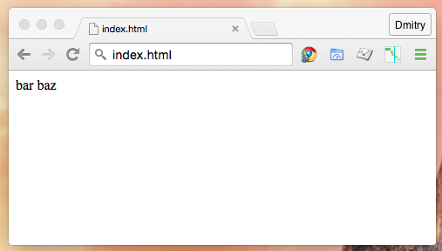
Insert Image B04886_02_01.png
Now we fiddle with more dependencies. So we create modules bar.js and baz.js:
bar.js
define({
value: "bar"
});

baz.js
define({
value: "baz"
});

We have to modify foo.js to access these modules
foo.js
define([ "./bar", "./baz" ], function ( bar, baz ) {
"use strict";
// Construction
return {
bar: bar.value,
baz: baz.value
};
});

As you noticed require/define dependency lists consists of module identifiers. In our case all the modules and the HTML located in the same directory. Otherwise we need to build the identifiers based on relative paths (file extension .js can be omitted). If you mess up with a path and RequireJS cannot resolve the dependency, it fires “Error: Script error for:<module-id>”. Not of much help, isn’t it? You can improve error handling by your own. A function expression passed next to the module scope callback receives exception object as an argument. That object has special properties requireType (a string containing the error type like "timeout", "nodefine", "scripterror") and requireModules (array of module ids affected by the error).
Error Handling
require([ "unexisting-path/foo" ], function ( foo ) {
"use strict";
console.log( foo.bar );
console.log( foo.baz );
}, function (err) {
console.log( err.requireType );
console.log( err.requireModules );
});

In well-grained design modules are numerous and allocated to a directory tree. In order to avoid relative path computation every time you can configure the script loader once. So the loader will know where to find the dependency file by a specified alias.
main.js
require.config({
paths: {
foo: "../../module/foo"
}
});
require( [ "foo" ], function( foo ) {
"use strict";
console.log( foo.bar );
console.log( foo.baz );
});

It gives a bonus. Now if we decided to change module file name we do not need to modify every other module that requires it, we just need to change the configuration:

main.js
require.config({
paths: {
foo: "../../module/foo-v0_1_1"
}
});
require( [ "foo" ], function( foo ) {
"use strict";
console.log( foo.bar );
console.log( foo.baz );
});

By configuring we can also address remote modules. For example, here we refer to jQuery, but RequireJS knows from the configuration the module endpoint and, therefore, loads the module from CDN.

require.config({
paths: {
jquery: "https://code.jquery.com/jquery-2.1.4.min.js"
}
});

require([ "jquery" ], function ( $ ) {
// use jQuery
});

Pros and Cons
The main advantage of AMD approach that modules load asynchronously. It also means, while deploying we don’t have to upload the entire code-base, but just a module changed. And since browser can handle multiple HTTP requests simultaneously, this way we improve performance… Yeah, here comes a huge trap. It’s really faster to load code in a few pieces parallel. But real-world projects have much more modules. With HTTP/1.1 protocol, which is still dominant at the moment, loading all of them would take unacceptably long. Unlike new standard SPDY and HTTP/2, HTTP/1.1 doesn’t cope really good with concurrency during the download of a page and in the case of a substantial queue it results in “head-of-line blocking” (https://http2.github.io/faq/). RequreJS provides a tool (http://requirejs.org/docs/optimization.html) to combine bunches of modules. This way we don’t need to load every single module, but a few packages. The dependencies packaged together are being resolved synchronously. So, one may say, that partly we abandon the main benefit of AMD - asynchronous loading. Meanwhile we must still load, usually quite heavy, script loader and wrap every single module with define() callback.
From my experience I would rather advice to go synchronous with Common JS modules, compiled into packages capable of in-browser use.

How to: synchronous modules on the server
The following examples require Node.js. It will take for just a few minutes to install Node.js by using pre-built installer https://nodejs.org/download/ or even faster via a package manager https://github.com/joyent/node/wiki/Installing-Node.js-via-package-manager
We will start with putting a simple logic into a module:
foo.js
console.log( "I'm running" );

Now we can call the module:
main.js
require( "./foo" );

In order to run the example we open the console (under Windows you can simply run CMD.EXE, but I would recommend an enhanced tool like CMDER http://gooseberrycreative.com/cmder/). In the console we type following:
node main.js

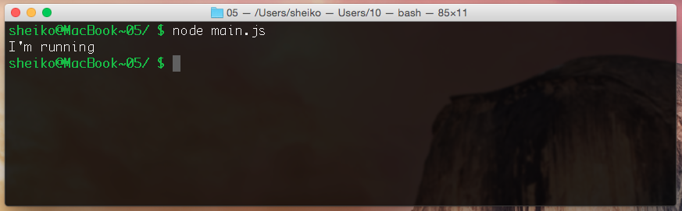
Insert Image B04886_02_02.png
As soon as Enter pressed it outputs “I’m running”. So when module is request its body code is invoked. But what if we request the module several times?

main.js
require( "./foo" );
require( "./foo" );
require( "./foo" );

The result is the same. It outputs “I’m running” only once. That’s because the module body code is executed only once when the module is firstly requested. An exported object (probably produced by the body code) is cached and acts very like a singleton:
foo.js
var foo = new Date();

main.js
var first = require( "./foo" ),
second = require( "./foo" );

console.log( first === second ); // true

As you likely noticed unlike AMD we don’t need any wrappers in modules. But is it still isolated from global scope?

foo.js
var foo = "foo";

main.js
require( "./foo" );
console.log( typeof foo ); // undefined

It’s. Any variables defined in a module scope are not available outside. However if you really want any shared between modules variables behind the exposed interface, you can do it via global object (Node.js analogue of in-browser windows object).
So what about export? CommonJS has preference for single export. We assign to module.exports a reference to a type or a value and that will be the cached return of the require function. If we want multiple exports, we just export an object:
foo.js
// module logic
module.exports = {
bar: "bar",
baz: "baz"
};

main.js
var foo = require("./foo");
console.log( foo.bar ); // bar
console.log( foo.baz ); // baz

The most common case in Node.js where an object constructor is exported:
foo.js
var Foo = function(){
this.bar = "bar";
}

module.exports = Foo;

So through require call we receive the constructor function with the prototype and can create instances
main.js
var Foo = require("./foo"),
foo = new Foo();

console.log( foo.bar ); // bar

The same way as we request module foo from main, we can do requesting from other modules:
bar.js
// module logic
module.exports = "bar";

baz.js
// module logic
module.exports = "baz";

foo.js
// module logic
module.exports = {
bar: require( "./bar" ),
baz: require( "./baz" )
};

main.js
var foo = require( "./foo" );
console.log( foo.bar ); // bar
console.log( foo.baz ); // baz

But what if Node.js runs into cyclic dependencies? What if we request back the caller from the callee? Nothing dramatic happens. As you remember a module code is executed only once. So if we request main.js from foo.js after main.js is already performed, its body code isn’t invoked anymore.
foo.js
console.log("Runnnig foo.js");
require("./main");

main.js
console.log("Runnnig main.js");
require("./foo");

When we run main.js with Node.js we get the following output:
Runnnig main.js
Runnnig foo.js

Pros and Cons
CommonJS has a concise and expressive syntax. It’s very easy to use. Unit-tests are usually written to run in the command-line and preferably are a part of Continuous Integration. A well-designed CommonJS module makes a perfect test-unit, that you can access directly from a Node.js-driven test framework (e.i Mocha) far out of the application context. But CommonJS implies synchronous loading, what is not suitable in a browser. If we want to bypass this limitation, we have to transpile modules sources into a single script that resolves module dependencies internally, without loading (see “CommonJS in a browser? Done!”).

UMD
If you want your module to be acceptable both in a browser as AMD and on the server as CommonJS, there is a trick (https://github.com/umdjs/umd). By adding a wrapper function you can dynamically build the export in a desired format depending on run-time environment.

Coming soon: JavaScript built-in module system
Well, both AMD and CommonJS are community standards, not a part of language specification. However with EcmaScript 6th edition JavaScript acquires its own module system. At the moment no browser yet supports this feature, so we have to install Babel.js transpiler to fiddle with the examples. Since we already have Node.js that distributed with NPM (Node.js package manager), we now can run following command:

npm install babel -g

Named exports
Now we can write a module:

foo.es6
export let bar = "bar";
export let baz = "baz";

In ES6 we can export multiple elements. Any declaration prefixed with the keyword export gets available for import.
main.es6
import { bar, baz } from "./foo";
console.log( bar ); // bar
console.log( baz ); // baz

Since we don’t have yet support for ES6 modules in browser we shall transpile them into CommonJS or AMD. Here Babel.js helps us:
babel --modules common *.es6 --out-dir .

By this command we made Babel.js to translate all the *.es6 files of the current directory into CommonJS modules. So we can run the derived main.js module with Node.js.
node main.js

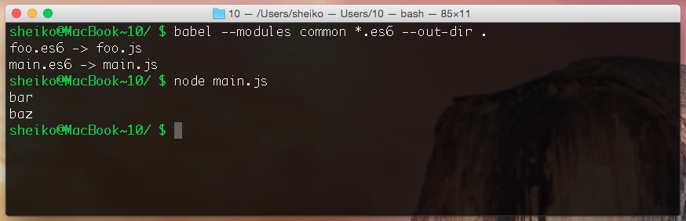
Insert Image B0886_02_03.png
Similarly we translate ES6 modules to AMD:
babel --modules amd *.es6 --out-dir .

index.html
<script data-main="./main"
src="https://cdnjs.cloudflare.com/ajax/libs/require.js/2.1.18/require.min.js"></script>

In previous example we enlisted in the import statement our named exports. We could also import the entire module and refer the named exports as properties.
main.es6
import * as foo from "./foo";
console.log( foo.bar ); // bar
console.log( foo.baz ); // baz

Default export
Besides we can also make a default export. That is how usually exports done in Node.js:
foo.es6
export default function foo(){ return "foo"; }

main.es6
import foo from "./foo";
console.log( foo() ); // foo

We exported a function and came with the import. It could also be a class or an object.
In AMD we receive exports as callback arguments, in CommonJS as local variables. ES6 though, doesn’t export values, but so-called bindings (references) that are immutable. You can read its value, but if you try changing it you get a type error. Babel.js triggers that error during compilation.
foo.es6
export let bar = "bar";
export function setBar( val ) {
bar = val;
};

main.es6
import { bar, setBar } from "./foo";
console.log( bar ); // bar
setBar( "baz" );
console.log( bar ); // baz
bar = "qux"; // TypeError

Module loader API
In addition to declarative syntax in a separate specification (https://github.com/whatwg/loader/) ES6 offers us a programmatic API. It allows programmatically working with modules and configuring module loading:
System.import( "./foo" ).then( foo => {
console.log( foo );
})
.catch( err => {
console.error( err );
});

Unlike Node.js ES6 modules due to their declarative nature require imports and exports at the top level. So it cannot be conditional. However with the pragmatic loader API we can do otherwise:
Promise.all([ "foo", "bar", "baz" ]
.map( mod => System.import( mod ) )
)
.then(([ foo, bar, baz ]) => {
console.log( foo, bar, baz );
});

Here we define a callback that is invoked only when all of the three specified modules loaded.

Polyfilling ES6 module dynamic loading
If you want to use ES6 module already, but don't want to mess with transpilation, you can go with ES6 Module Loader Polyfill (https://github.com/ModuleLoader/es6-module-loader). The polyfill enables ES6 loader support in popular transpilers such as Traceur, Babel and TypeScript:
<!-- load babel -->
<script src="node_modules/babel-core/browser.js"></script>
<!-- load the polyfill -->
<script src="es6-module-loader-dev.js"></script>
<script>
// Let the polyfill know it's Babel
System.transpiler = "babel";
// Import from fooModule foo export
System.import( "fooModule" ).then(function( foo ) {
console.log( foo );
});
</script>

Conclusion
Both AMD and CommonJS are interim standards. As soon as the JavaScript build-in module system gets wider support in script engines we don’t really need them anymore. ES6 modules load asynchronously and the loading can be configured similar to AMD. They also have a compact and expressive syntax and support for cyclic dependencies similar to CommonJS. In addition ES provides declarative syntax for static module structure. Such structure can be statically analyzed (static checking, linting, optimization, etc.). ES6 also provides a programmatic loader API. So you can configure how modules are loaded and load modules conditionally. Besides, ES6 modules can be extended with macros and static types.
While everything looks so unclouded, there is a fly still in the ointment. ES6 modules can be pre-loaded synchronously (with <script type="module"></script>), but the common case implies asynchronous loading and that brings us to the same trap as in the case of AMD. Numerous requests over HTTP/1.1 make a harmful effect on user response time (https://developer.yahoo.com/performance/rules.html). In the other hand, SPDY and HTTP/2 that allow multiple requests per TCP connection are getting wider support and eventually will take the place of dubious HTTP/1.x. Furthermore W3C works on standard called “Packaging on the Web” (https://w3ctag.github.io/packaging-on-the-web/) that described how an archived files (scripts) can accepted from a URL (hash). So we will be able to bundle the whole directory with modules into an archive, deploy and address them the same way as we do when having them in a directory.

Traspiling CommonJS for in-browser use
While HTTP/2 and “Packaging on the Web” on their ways yet we need fast modular applications. As it was mentioned above we can divide the application code into CommonJS modules and transpile them for in-browser use. The most popular CommonJS transpiler is surely Browserify (http://browserify.org). The initial mission of that tool was to make Node.js modules reusable. They quite succeed. It may feel like a magic, but you can really use EventEmitter and some other Node.js core modules on the client. However with the main focus on Node.js compatibility the tool provides too few options for CommonJS compilation. For example if you want dependency configuration you have to use a plugin. In real-world project you likely end up with multiple plugins and where each has a specific configuration syntax. So the setup in general gets overcomplicated. We’ll rather examine here another tool called CommonJS Compiler (https://github.com/dsheiko/cjsc). That’s a considerably small utility designed to bring CommonJS modules into browser. The tool is very easy to configure and use, what makes it a good choice to illustrate the concept.
First of all we install Cjsc:
npm install cjsc -g

Now we can take an example from “How to: synchronous modules on the server” section and transpile it for in-browser use:
bar.js
// module logic
module.exports = "bar";

foo.js
// module logic
module.exports = {
bar: require( "./bar" )};

main.js
var foo = require( "./foo" );
document.writeln( foo.bar ); // bar

The start-point is main.js. So we tell Cjsc to bundle this module with all the required dependencies recursively into bundle.js
cjsc main.js -o bundle.js

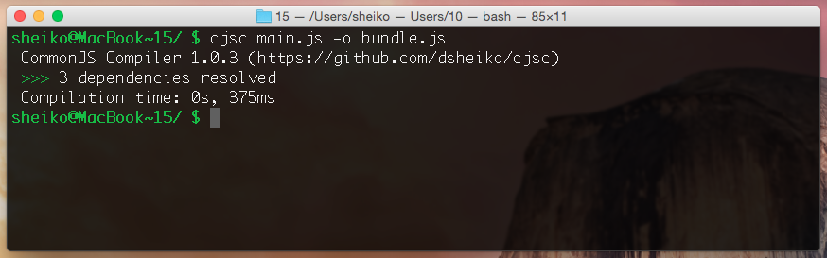
Insert Image B04886_02_04.png
Let’s peep into the generated file. Cjsc replaced all the require calls with custom _require and put into the beginning _require function definition. This little trick allows you to run the compiled code in Node.js/Io.js friendly environment like NW.js, where `require` function still needed for local packages. Every module is wrapped in a function scope supplied with module relevant objects (exports and module) plus global, which a reference to the global object (window).
Compiled Code
_require.def( "main.js", function( _require, exports, module, global ){
var foo = _require( "foo.js" );
console.log( foo.bar ); // bar
console.log( foo.baz ); // baz
return module;
});

The generated code is a generic JavaScript that we can surely address from the HTML
index.html
<script src="bundle.js"></script>

Our sources are still CommonJS module. It means we can access them directly from a Node.js-based framework for unit-testing.
Mocha.js Test (http://mochajs.org/)
var expect = require( "chai" ).expect;
describe( "Foo module", function(){
it( "should bypass the export of bar", function(){
var foo = require( "./foo" );
expect( foo ).to.have.property( "bar" );
expect( foo.bar ).to.eql( "bar" );
});
});

Cjsc has a number of options. But in real project typing with every build a long command-line would be annoying and unproductive:
cjsc main-module.js -o build.js --source-map=build/*.map \
--source-map-root=../src -M --banner="/*! pkg v.0.0.1 */"

That is why use task runners such as Grunt, Gulp, Cake, Broccoli. Grunt (http://gruntjs.com) is the most popular task runner at the moment and has an overwhelming number of plugin available (Grunt vs Gulp infographic http://sixrevisions.com/web-development/grunt-vs-gulp/). So we install grunt command line interface globally:
npm install -g grunt-cli

In order to setup a Grunt project we need two configuration files package.json (https://docs.npmjs.com/files/package.json) and the Gruntfile.js. The first one contains metadata about NPM packages required to run Grunt tasks. The second is needed to define and configure the tasks.
Here we can start with very minimalistic package.json that has only an arbitrary project name and its version in semver (http://semver.org/) format:
package,json
{
"name": "project-name",
"version": "0.0.1"
}

No we can install required NPM packages:
npm install --save-dev grunt
npm install --save-dev grunt-cjsc

Thus we get local Grunt and a Grunt plugin for CommonJs Compiler. This special option --save-dev creates in package.json section devDependencies (if it doesn’t exist) and populates it with the installed dependency. So when, for an instance, we pull the projects sources from a version control system we can restore all the dependencies by simply running `npm install`.
In the Gruntfile.js we have to load already installed grunt-cjsc plugin and configure a task called cjsc. In practice we will need at least two targets providing different configurations for this task. The first one `cjsc:debug` runs cjsc to produce uncompressed code, provided with source map. The second `cjsc:build` we use to prepare assets for deployment. So we get minified code in bundle.js.
Gruntfile.js
module.exports = function( grunt ) {
// Project configuration.
grunt.initConfig({
pkg: grunt.file.readJSON( "package.json" ),
cjsc: {
// A target to generate uncompressed code with sources maps
debug: {
options: {
sourceMap: "js/*.map",
sourceMapRoot: "src/",
minify: false
},
files: { "js/bundle.js": "js/src/main.js" }
},
// A target to build project for production
build: {
options: {
minify: true,
banner: "/*! <%= pkg.name %> - v<%= pkg.version %> - " +
"<%= grunt.template.today(\"yyyy-mm-dd\") %> */"
},
files: { "js/bundle.js": "js/src/main.js" }
}
}
});

// Load the plugin that provides the task.
grunt.loadNpmTasks( "grunt-cjsc" );

// Make it default task
grunt.registerTask( "default", [ "cjsc:build" ] );

};

As you can see from the configuration cjsc is intended to transpile js/src/main.js into js/bundle.js. So we can take the module of the previous example and copy them into ./js/src.

Now when we have everything on place, we run a task. For example:
grunt cjsc:debug

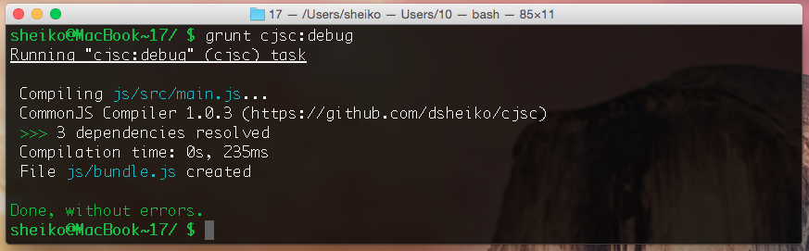
Insert Image B04886_02_05.pmg
As mentioned we can configure dependency mapping with Cjsc. We just need to describe the dependencies in object literal that can be supplied to Cjsc as JSON-file in command-line interface or injected into Grunt configuration.
{
"jquery": {
"path": "./vendors/jQuery/jqueiry.js"
},
"underscore": {
"globalProperty": "_"
},
"foo": {
"path": "./vendors/3rdpartyLib/not-a-module.js",
"exports": [ "notAModule" ],
"imports": [ "jquery" ]
}
}

Here we declare alias (shortcut) “jquery” for a module located in "./vendors/jQuery/jqueiry.js". We also state that a globally exposed “_” (Underscore.js) library to be treated as a module. At the end we specify path, exports and imports for a 3rd party component. Thus we get it into the app (without intervention in its code) as a module, though it’s not.
cjsc main.js -o bundle.js --config=cjsc-conig.json

Grunt configuration
grunt.initConfig({
cjsc: {
build: {
options: {
minify: true,
config: require( "fs" ).readFileSync( "./cjsc-conig.json" )
}
},
files: { "js/bundle.js": "js/src/main.js" }
}
});

Bundling ES6 modules for synchronous loading by now
Well, as we cleared up in “Coming soon: JavaScript built-in module system” section, ES6 modules are to replace AMD and CommonJS standards. Moreover, we can already write ES6 code and transpile it into ES5 for now. As soon as support for ES6 across script agents is good enough, we theoretically can use our code as it is. But what about performance? In fact we can compile ES6 modules in CommonJS and then bundle them with Cjsc for in-browser use.
foo.es6
export let bar = "bar";
export let baz = "baz";

main.es6
import { bar, baz } from "./foo";
document.writeln( bar ); // bar
document.writeln( baz ); // baz

First we compile ES6 into CommonJS modules
babel --modules common *.es6 --out-dir .

Then we bundle CommonJS modules into a script suitable for in-browser use.
cjsc main.js -o bundle.js -M

Summary
Modular programming is a concept closely related to OOP that encourages us on structuring code for better maintainability. In particularly JavaScript modules prevent global scope from pollution, divide application code into multiple files and allow reuse of application components.
Two module API standards mostly used at the moment are AMD and CommonJS. The first one designed for in-browser use assumes asynchronous loading. The second is synchronous and intended for server-side JavaScript. However one should know that AMD has a substantial flaw. A well-grained application design with plenty of modules over HTTP/1.1 may bring to a disaster in terms of application performance. That is the major reason why recently the practice of transpiling CommonJS modules for in-browser use is on the rise.
Both these APIs shall be considered as interim standards, because the upcoming ES6 modules standard is meant to replace them. At the moment there is no script engines supporting this feature, but there are transpilers (e.g Babel.js) that allow to translate ES6 modules into CommonJs or AMD.

